**Indoor-outdoor thermometer**

## **Step 1: Make it**

### **What is it?**

Use two micro:bits so you can monitor outdoor temperatures remotely.

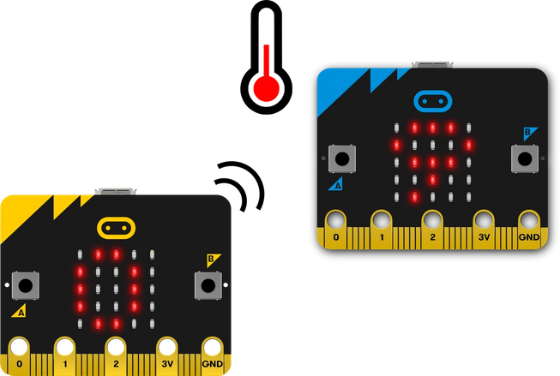

### **How it works**

* This project uses two different programs, one for the outdoor micro:bit which senses the temperature and transmits it on radio group 23.
* The outdoor micro:bit uses its temperature sensor to measure how hot or cold it is.
* It uses [radio](https://microbit.org/get-started/user-guide/features-in-depth/#radio) to send this temperature reading to the indoor micro:bit.
* When the indoor micro:bit receives a temperature reading from outside, it stores it in a **variable** called **outdoorTemp**.
* When you press input button A on the indoor micro:bit, it shows its own current temperature reading on its LED display output.
* When you press button B, it shows the temperature reading from outside that it has stored in the **outdoorTemp** variable.

### **What you need**

* Two micro:bits
* MakeCode or Python editor
* battery pack
* A waterproof container, such a plastic box

## **Step 2: Code it**

### **Outdoor sensor and transmitter:**

### **Indoor sensor and receiver:**

## **Step 3: Improve it**

* Make the batteries last longer by having the outdoor micro:bit turn its radio off when it’s not in use and sending temperature readings less often.
* Use variables to track the highest and lowest temperatures recorded.
* Calibrate the readings against another thermometer to see if you need to adjust the micro:bit’s temperature.